Our Proposal

—
Introduction
As CRCL continues to expand, with multiple operational agencies and over 100 providers across the province, we recognize the importance of creating a secure, scalable, and accessible digital platform that can unify communication, support data integrity, and enhance coordination between service providers and the provincial oversight team at CMHA BC.
Our team’s experience in building robust digital solutions for health and community organizations positions us well to deliver a platform that meets the highest standards of privacy, security, and usability. We aim to design a solution that streamlines information flow between CRCL teams, aligns with Government privacy and security requirements, and ultimately supports the program’s mission to provide responsive, compassionate, and community-led crisis care.

—
Project Goals
To develop a centralized, secure online platform (accessible via web and mobile) that enables all CRCL staff (100+ users) to:
- Manage and store case data securely within a unified database.
- Automate report generation with real-time analytics and export options.
- Access internal resources such as documentation and training materials.
- Coordinate and manage dispatch operations efficiently through role-based workflows.

—
Stakeholders and Roles

Role | Responsibilities
Person in Crisis | Initiates a call or text seeking support.
Dispatcher | Answers crisis calls, assigns responders, schedules follow-ups, and closes cases. Conducts 24–48 hour check-ins and determines if further support is needed.
Crisis Responder | Provides on-site crisis support and logs case details in the system.
Agency Manager | Adds/Removes Crisis Responders. Reviews closed cases and submits data to CMHA.
CMHA / Province | Reviews aggregated reports from agencies for oversight and quality assurance.

—
Interfaces & Technology Stack
- Frontend Interface: React.js for dynamic and responsive user interfaces
- Mobile App Interface: ReactNative using Expo.Dev framework.
- Backend Interface: Nest.js or Node.js for server-side logic
- Hosting: AWS Canada for data storage using ca-central-1 (Toronto) and ca-west-1 (Calgary) regions, using AWS ECS
- Database: MySQL, PostgreSQL & MongoDB for scalable and flexible data management using AWS RDS
- Email Service: Amazon Simple Email Service (SES) for email notification services
- SMS Service: Amazon Simple Notification Service (SNS) for 2-way SMS notification services
- Chatbot: WhatsApp Business API for automated intake using Twilio (Optional)
- Location & GPS: Google Maps integrations
- Logging: AWS CloudTrail

—
Scope of Work
The CRCL system provides:
Structured Digital Workflow
- Implement an end-to-end digital workflow for crisis intake, dispatch coordination, and reporting.
- Ensure each stage (intake → assessment → response → closure) is tracked and auditable.
Role-Based Access Control
- Define specific permissions and access levels for Dispatchers, Responders, and Agency Managers.
- Limit visibility and edit rights based on user roles to maintain data integrity and confidentiality.
In-App Chat and SMS Integration
- Build a secure chat module for more organized and secure internal team communication
- Integrate with hotline SMS to allow Dispatchers to receive and send messages to the Person in Crisis through the web portal
Secure Data Management & Reporting
- Ensure encrypted, centralized storage of all case and communication data.
- Implement automated reporting features to generate and submit required reports to CMHA and other relevant authorities.

—
Deliverables Summary Table

Deliverable | Title / Name | Requirements / Deliverables
Deliverable 1 | Intake & Core Platform Setup | - Secure web platform for crisis intake and case management.  - User authentication and permissions  - Automated intake through secure web form or Whatsapp  - Manual intake through hotline  - Unified case tracking with unique IDs and statuses.  - Dispatcher dashboard for active and pending cases.  - Role-based access control and user authentication.  - Data encryption, audit logs, and basic reporting (volume, response time, closures).  - Automated follow-up scheduling and system administration tools.
Deliverable 2 | Responders Mobile Application | - Mobile app for responders.  - Real-time sync between web and mobile.  - Real-time case updates and responder status tracking.  - GPS mapping for responder proximity and dispatch.  - Case details, location navigation, and live status updates in the app.  - Timestamps for each stage: call, dispatch, travel, arrival, completion.
Deliverable 3 | In-App Chat & SMS Integration) | - Secure real-time messaging between dispatchers and responders.  - Supports text, file, and image sharing with end-to-end encryption.  - Integrated with case records for seamless communication tracking.  - SMS two-way communication integration with the in-app chat module  - Role-based access, audit logs, and compliance-ready data storage.
Deliverable 4 | Centralized Reporting & Analytics | - Centralized reporting hub.  - Real-time dashboards for performance monitoring.  - Data filtering by date, region, type, and responder.  - Power BI or internal analytics for visualization.  - Standardized reports for compliance and insights.  - Track assignment and transition times across all case stages.

—
Deliverable 1 (Intake & Core Platform Setup)

Objectives
- Centralize all crisis intake, dispatch, and reporting operations in one secure platform.

Centralized CRCL Database System
We propose building a secure, Canadian-hosted web and mobile database platform with the following qualities:
- Hosted on a Canadian server or local (on-premise) if needed
- Fully encrypted & privacy-compliant to meet government standards.
- Reliable and scalable with backups and support for large simultaneous use.
- Affordable & user-friendly so staff can be trained and learn quickly.
We shall create a custom-built, cloud-based system with strong privacy and encryption using AWS Canada. It will replace the spreadsheets and emails with one portal.
Case Management Module
Similar to an internal “medical record” system for crisis response. Each responder can securely document what happened, and dispatchers can assign and send requests easily.
We shall build:
- Secure logins with different user access levels.
- Ability for each CRCL responder to record all details of a crisis call
- Track referrals and follow-ups.
- Ability to open, close, and search client files.
- Audit logs to view all activities.
- Dispatchers can assign cases to responders.
- System marks repeat users automatically.
- Length of intake call (Based on status change time delta calculation)
- Exporting reports in Excel/CSV.
Document Center
This is basically an internal resources hub easy access for staff to documents instead of sharing through email.
We shall create a secure library that replaces SharePoint. It will allow:
- Staff to log in and access training materials, policies, forms, etc.
- A “spotlight” section to highlight new or important resources.
- A place to upload case related documents.

Functional Requirement | Description
Support Request Intake | Users in crisis can initiate support requests through multiple channels. Dispatcher opens a new case for each request.
Automated Case Via Secure Form | A case is automatically opened once a user fills out a secure web form.
Unified Case Management | Each new request automatically generates a unique Case ID linked to the caller’s details and communication history. Cases must have defined statuses.
Dispatcher Dashboard | The system provides a web-based dashboard showing all active, pending, and closed cases, with real-time updates and filtering by urgency, channel, and region.
Dynamic Case Form | The case creation form must display context-sensitive questions based on crisis type (routine, emergency, sensitive). Form data should auto-save and support partial submissions.
Follow-Up Scheduling | Dispatchers must be able to set follow-up reminders (24–48 hours), view them in their dashboard, and mark them as completed once the follow-up is done.
Case Assignment | The system must allow dispatchers to assign cases to responders or mark them as self-managed (follow-up only). Assignment changes should trigger system notifications.
User Authentication | The platform must use secure authentication (JWT / OAuth2). Only verified users (Dispatchers, Managers, CMHA Admins) can access system features.
Role-Based Access Control | Each user role (Dispatcher, Agency Manager, CMHA Admin) should have restricted permissions based on their responsibilities and data access needs.
Data Encryption | All sensitive information (personal data, case notes, call logs) must be encrypted at rest (AES-256) and in transit (HTTPS).
Audit Logging | All actions (case updates, status changes, assignments) must be logged with user ID, timestamp, and action details for traceability.
Basic Reporting | The system must generate simple visual and tabular reports for case volume, average response time, and closure rates. Reports can be exported as CSV or PDF.
System Administration | Admin users must be able to manage user accounts, edit system settings (regions, crisis types), and access full audit trails.

—
Deliverable 2 (Responders Mobile Application)

Objectives
- Mobile App for Crisis Responders providing a secure dispatch management system.
- Enable real-time responder location tracking and accurate time logging.
- Improve response efficiency through GPS-based assignment and live status updates.
Crisis Responders notifications and updates
- The app shall allow real-time alerts and notifications when a new crisis call or case is assigned to a Responder.
- Responders should be able to:
- Receive and accept or decline cases instantly.
- Access case details, location, and notes securely.
- Update case status (on route, on site, resolved, follow-up needed).
- Log session details and upload reports or notes after the response.
Dispatch location tracking module
- Travel time to the person in crisis (Based on status change time delta calculation). This is done through a built-in GPS / Map integration for location tracking.
- On-site response time (Based on status change time delta calculation)

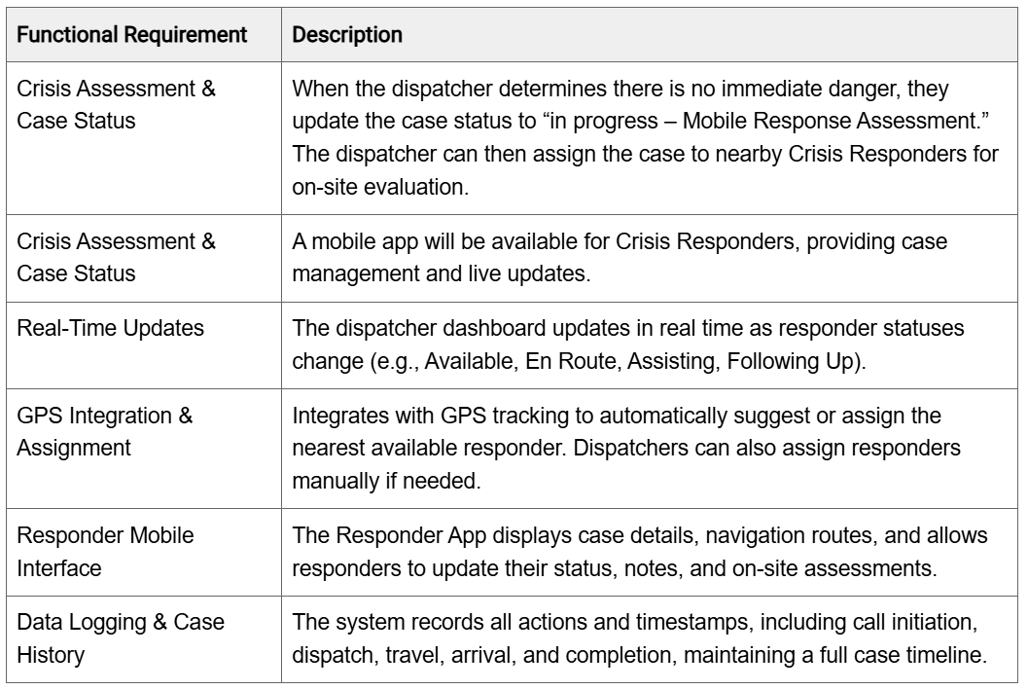

—
Deliverable 3 (In-App Chat & SMS Integration)

Objectives
- Enable secure, real-time communication between dispatchers and responders directly within the CRCL platform to eliminate the need for WhatsApp Business
- SMS Integration with the in-app chat system to allow dispatcher to communicate with Person in Crisis via the web app chat
Internal In-App Chat System (Web App and Mobile App)
We propose building a fully encrypted, privacy-compliant internal messaging feature that allows for seamless coordination during and after crisis response. The chat will be lightweight, fast, and integrated into the existing CRCL platform.
We shall build:
- Secure one-on-one and group chat between dispatchers and responders.
- End-to-end encryption for all messages to ensure confidentiality and compliance with government privacy standards.
- File and image sharing to allow the exchange of documents, forms, or photos related to a case.
- Message history linked to case IDs, allowing easy reference within the case record.
- Real-time notifications for new messages and attachments.
- Simple and responsive interface optimized for both web and mobile devices.
- Automatic log and audit tracking for communication records to maintain accountability and traceability.
SMS Integration (Two-Way Text Messaging System)
We propose integrating a secure SMS gateway that allows individuals in crisis to communicate directly with CRCL dispatchers through text messages. All SMS messages will automatically appear in the internal chat system, enabling dispatchers to respond directly from the web app. This eliminates the need for a dedicated phone device and centralizes all communication within the CRCL platform.
We shall build:
- Automatic synchronization of all SMS messages into the in-app chat interface.
- Ability for dispatchers to reply to SMS messages directly from the CRCL web app.
- Message threading that keeps SMS conversations linked to the related case record.
- End-to-end encryption and secure data handling for all SMS communications.
- Real-time notifications for incoming texts to ensure prompt dispatcher response.
- Full message logging and audit tracking for compliance and accountability.
- Centralized communication dashboard accessible by authorized users only.

Functional Requirement | Description
User Interaction | The system shall allow users to send and receive real-time text messages.
User Interaction | The system shall support one-on-one chat between dispatchers and responders.
User Interaction | The system shall support group chats for multi-responder coordination.
User Interaction | The system shall allow users to upload and share files and images.
User Interaction | The system shall notify users of new messages via real-time alerts.
User Interaction | The system shall restrict chat access based on user roles and permissions.
User Interaction | The system shall be accessible via both web and mobile interfaces.
User Interaction | The system shall link chat history to the corresponding case ID.
User Interaction | The system shall allow users to search messages by keyword or case ID.
Data Processing | The system shall encrypt all messages and attachments end-to-end (only with applicable transfer methods).
Data Processing | The system shall log all chat activity for audit and compliance purposes.
Data Processing | The system shall display message timestamps.
User Interaction | The system shall automatically receive incoming SMS messages from external users.
User Interaction | The system shall display incoming SMS messages within the in-app chat interface.
User Interaction | The system shall allow dispatchers to reply to SMS messages directly from the web app.
User Interaction | The system shall send dispatcher replies back to the external user via SMS gateway.
User Interaction | The system shall maintain a continuous message thread for each phone number.
User Interaction | The system shall link each SMS conversation to the corresponding case ID.
User Interaction | The system shall trigger real-time notifications for new incoming SMS messages.
User Interaction | The system shall allow multiple dispatchers to view and respond to the same SMS thread.

—
Deliverable 4 (Centralized Reporting & Analytics)

Objectives
- Automate reporting and performance tracking for CRCL and CMHA.
- Enable advanced data filtering by date, region, crisis type, and responder.
- Track time across all case status transitions for auditing and analytics.
- Provide data-driven insights through integrated analytics and dashboards.
Reporting & Dashboard Module
Flexible reporting for government compliance and program tracking.
We shall build:
- Export reports in Excel/CSV.
- Real-time dashboards showing live data in tables, charts, and graphs.
- A database compatible with PowerBI for CMHA analytics as needed

Functional Requirement | Description
Centralized Reporting System | centralize all reporting functions, eliminating the need for manual spreadsheets.
Real-Time Data Visualization | real-time dashboards displaying key operational data across all participating agencies, accessible through the web app.
Historical Trend Analysis | historical data visualization and trend analysis to evaluate performance over time and identify recurring patterns or operational bottlenecks.
Data Filtering and Segmentation | advanced data filtering options by date, region, crisis type, and responder, enabling targeted reporting and analysis.
PowerBI-Ready Database | PowerBI compatible database with automated sync every 10 minutes
Response Time Calculation | Automatically calculate total response and resolution times for each case to support performance evaluation and required reporting to CMHA.
Assignment Tracking | track and record the time elapsed between each case status transition. All timestamps and duration calculations must be automatically stored in the case history to support performance analytics, auditing, and reporting.
Dispatcher Dashboard Integration | Dispatcher Dashboard must display all available responders and their live GPS locations on a map, while recording all key timestamps —including call start, dispatch, travel, arrival, and completion — for every case.

—
User Relationships Overview

Section | Interactions details
User → System | - Users can reach the system through multiple channels:  - Hotline (phone call)  - Website request form  - Dispatcher completes a dynamic case form  - Dispatcher selects which questions to ask based on their assessment to the situation  - After assessment, the dispatcher decides whether to:  - Assign a Mobile Responder  - Mark for Follow-Up  - Take No further action  - Escalate to emergency response units  - If follow-up is required, the Dispatcher personally handles it.
Dispatcher ↔Responder | - When on-site assistance is needed, the Dispatcher creates a responder request.  - The system automatically assigns the task to responders closest to the user’s location for faster response.
Responder ↔ User | - Responders can accept nearby cases directly through the mobile app.  - After the visit, the responder submits detailed case reports about the condition during and after the visit.
System ↔ Responder | - Once a visit is marked as complete, the system automatically schedules a follow-up within 24–48 hours.  - This ensures continuous care, proper case tracking, and timely updates for the Agency Manager and CMHA.
Agency Manager ↔ Team (Dispatchers & Responders) | - Agency Managers oversee their local CRCL team’s activities.  - They can view case progress, team performance, and response timelines.  - Receive alerts for overdue follow-ups or unresolved cases.  - Manage staff permissions, ensure documentation quality, and support compliance with privacy standards.  - Review reports and summaries before submission to CMHA Admin.
CMHA Admin ↔ Agencies | - CMHA Admins have tiered access to view all agency dashboards.  - They can monitor aggregated data across regions.  - They export reports (Excel/PDF) using custom filters (date, region, case type, etc.).  - CMHA Admins ensure that provincial reporting standards are met.  - Can communicate with Agency Managers for clarification or follow-up.
CMHA Admin ↔ Province | - CMHA Admins submit aggregated, anonymized data to the Province via Power BI dashboards. This communication between CMHA and the Province is done outside of this application.  - Reports include metrics such as:  - Number of crises handled  - Response time averages  - Outcomes and follow-up rates  - The Province reviews data trends to evaluate program impact and determine funding or expansion decisions.

System Architecture and Workflows

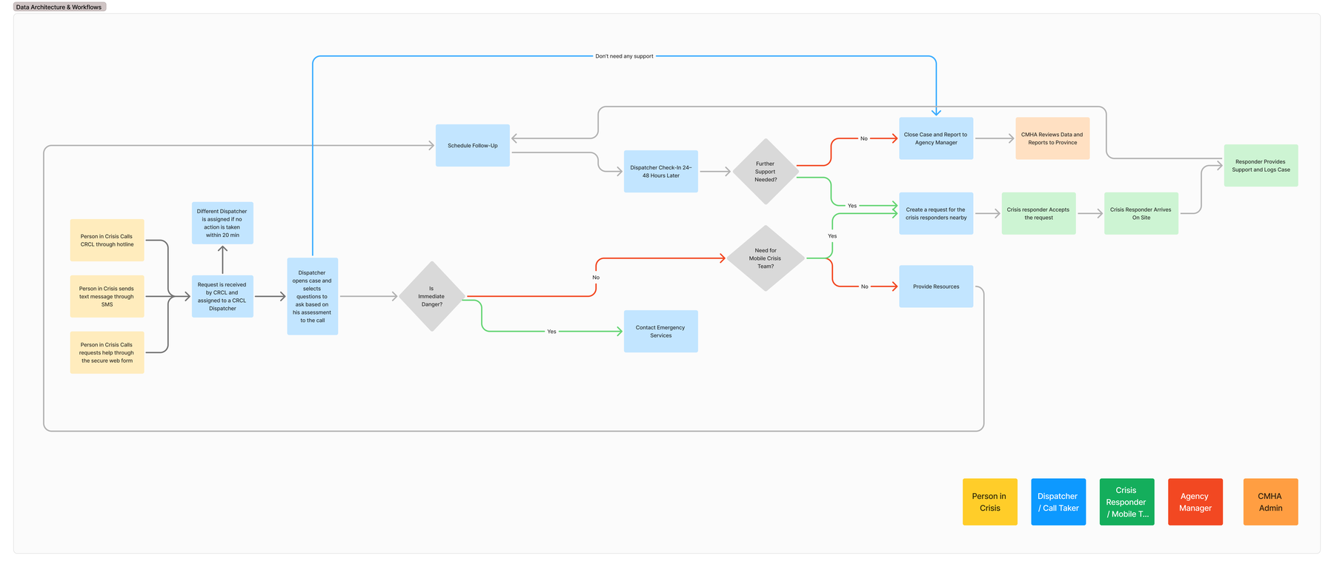

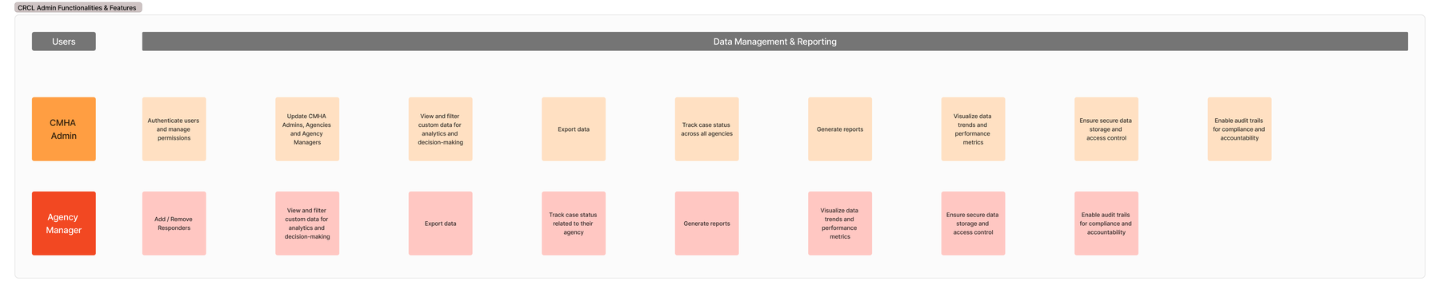

System Statuses and Permissions

